Ida Berg, Jonathan Lindström, Maria Wurm| International Communication | 25. Juni 2016

Refugee Support Project
  - Media press mirror
  - Preface
The media and the press are shaping and influencing every day public’s opinion about something. People are surrounded with media, like radio, television, newspapers and not to forget the internet and social media platforms. To contribute to the Refugee Support Project from the University of Innsbruck our group analyzed how the media and the press deal with that topic.
We have read several online articles about migrants, refugees and related themes from different newspapers from November 2015 till May/June 2016. Ida and Jonathan focused on international and finish newspapers and Maria focused on the German and Austrian region.
First we created a google document, shared it and we collected a lot of articles and news about refugees. For example, articles about refugee’s home, migration methods and political issues. Thereby we looked for articles with the same topic and tried to find out the differences between the various media houses.
This paper should summarize the outcome of the complex collection of articles and news, due to the fact that we don’t have infinite space. So we just publish some articles, where we found differences between the various media houses and which we found interesting to share.

Some of the most interesting articles that I found in the European media were in the British media, and published in the Guardian. One specific thing that I noticed looking through the articles published between November 2015, and May 2016, was that the tone of the articles changed. The articles from November 2015, were mainly discussing the issues of the refugee crisis, focusing on the negative aspects, whereas the articles from February to May, were more focused on solutions for the refugee crisis.
In November 2015, The Guardian published two articles, both concerning the financial issues of the refugee crisis. On the 5th of November, an article named “EU states failing to meet funding and resource commitments” was published, which discussed how the Member States of the EU were falling short of all the main commitments that they agreed to in September, when they tried to urgently address the refugee crisis. The Guardian, 2015a) The other article in The Guardian was published on the 13th of November with the title “EU urged to focus funds on displaced Syrians in Middle East”. This article discussed how EU leaders debated migration in Malta, in order to reinforce the infrastructure of countries that were struggling to hos millions of Syrians. (The Guardian, 2015b) Using such words as “failing” and “urged”, instantly give the reader a negative image of the content in the article in question.
Another British magazine, slightly less plausible than The Guardian, wrote an article in November about a woman who had gathered 500,000 signatures on a petition to close the UK border’s for all immigrants, further prompt the anti-immigration “trend”. (The Daily Mail, 2015) However, in the Finnish media, there were some articles regarding the refugee crisis, written in a more positive tone. One that was published 21st of November, had the title “Refugees’ restaurant became a hit on this years’ restaurant day” (translated from Finnish), and conveys how a group of refugees opened up their own restaurant “stall” on a popular event in Helsinki. (Helsingin Sanomat, 2015) This article moves the focus to the refugees making an effort to integrate in the society.
When looking at the articles published in March and April, I found several, that were no longer focusing on the negative aspects of the refugee crisis. On the 5th of March, 2016, The Guardian published an article with the title “Austria expatriates in Greece condemn Vienna over refugee crisis”. This article discusses the reactions of Austrians living abroad, being extremely upset over the manner in which Austrians are handling the refugee crisis. They described Vienna’s strong-arm approach as callous and deeply embarrassing. (The Guardian, 2016a) Even though this article points out that the Viennese population has not handled the refugee crisis well, it does not bring out the negative aspects of the refugees, but rather points out that EU Member States could be doing a better job in welcoming these refugees.
Another article published in The Guardian on the 12th of March 2016, with the title “How Greeks opened their hearts to strangers” discusses how the Greeks have shown astonishing generosity in helping over 40,000 refugees stranded in Greece. (The Guardian, 2016b) This article focuses on the difficult and unimaginable situation the refugees are in, and that the reaction of the Greeks has been extremely positive and helpful. The article vividly describes how young children were starving and cold and how the refugees were suffering, making it an obvious decision to help them.
Articles like this are more powerful than one could imagine as readers might understand that the people that really are in danger, are the refugees and that they truly need the support of other states. Another similar article was published on the 15th of April, 2016 with the title “The idealists of Lesbos: volunteers at the heart of the refugee crisis”. (The Guardian, 2016c) This article also discusses the 50,000 volunteers that have been helping out in the refugee crisis, and criticizes European countries for not being willing to help refugees in a proper way. When looking at the two latter headings, they both include the word heart, which is a soft word that, rather than spreading uncertainty and anger, spreads the feeling of hope.

I was doing a short analysis on how the newspapers are receiving more attention when mentioning about asylum seekers. This was done by finding articles regarding molesting and raping. The articles mentioning about an asylum seeker asylum was then compared with articles not mentioning about asylum seekers. Because of the lack of statistics on how many “clicks” the headline got, I tried to evaluate the popularity of the article based on the comments. The analysis was aimed to Finnish newspapers, both local and more nation wide papers. Below we find a summary about the articles. A short description of the analysis is presented below.
In the first article, an Asylum seeker is suspected of raping a 14-year old girl in Raisio, Finland. The article was released 28.11.2015. The Asylum seeker has at this point been staying in Finland for one year. The words “asylum seeker” was already mentioned in the headline and this article had 72 comments.
Next article, which is a sequel of the Raisio rape, had 9 comments from the readers regarding the title. This article is dated 12.1.2016. The Title in English: “The Raisio rape investigation is complete: The Asylum seeker is now suspected for aggravated rape”. The same Asylum seeker is now suspected for aggravated rape. According to HS the main trial will continue in February. Related to the HS title from 28.11.2015. This news story was reported from Turun Sanomat (12.1.2016) as well. Turun Sanomat used only “a 19-year old” instead of “Asylum Seeker”.
The last article is about when the same asylum seeker was found guilty. He was sentenced to three years and three months in prison as a punishment. Related to the HS title from 28.11.2015. In this headline they do not use Asylum seeker, only “the man” but they are mentioning that it is the same case, giving the reader the information indirectly. This article has 24 comments.
In the comparison article, from Turun Sanomat (16.2.2016) They are talking about the same case. However, they don't use asylum seeker in the Title but both newspapers are mentioning the asylum seeker in the body text.
I took a fifth article into account when doing the analysis. This news story is also a comparison with the Raiso case. This title (3.5.2016) says that a man who worked in a bar named Tivoli in Finland is suspected of aggravated rape. This news story has not been updated with new titles regarding the same subject. Neither has Helsingin Sanomat, the nation wide paper, written anything about it. The comments from the readers on this story is 12, compared to over 70 comments in the first article about the asylum seeker in Raisio.
What was really interesting to see was that there is a difference in interest if the paper writes about a refugee or a native man or woman. One could argue that people are generally more careful about new cultures and people and thus behaves like we have seen. One can also see that in the comment fields, there is usually discussion just about the fact that the perpetrator was a foreigner. Living in unstable political and economical times, it is usually easier to find the guilty from an outsider, from another culture in this case.
Another thing we have to understand is the culture of “clicking”. When the newspapers internet articles are profitable just because their advertising companies are paying a sum every time someone clicks on the link, it is understandable that, in a free market, they are seeking to maximize their profits. As long as the people are reading, the newspapers will continue to produce these articles that are in the people´s interests. This is really important to understand when discussing newspapers power or etic. To be able to change the newspapers attitude, the readers have to change their attitudes and reading habits on the web.

Nowadays social media and the internet plays a major role about how new get spread and social platforms have a great impact on influencing people’s mind about something.
The Austrian Start-up Storyclash, calculated for the year 2015, which news or articles from the press/media became the most interactions, reactions, shares and comments in the social media platform Facebook, Twitter and co.
The biggest media houses in Austria derstandard.at, oe24.at, tagespresse.com and krone.at are in the top 50 of this ranking with their articles and news, which received a very fast distribution via social media.
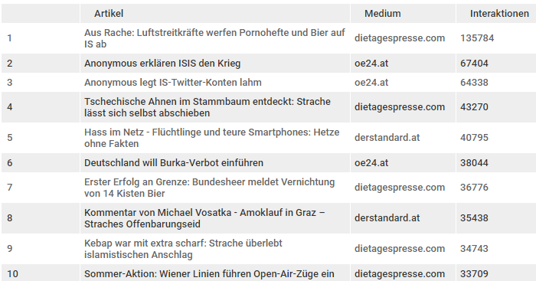
In the graph below you can see the shares and likes from June 2015 till January 2016. Moreover, the diagram shows that articles with a positive relation (blue) to refugees got the most likes and shares in June, July and August 2015. Since September 2015, articles and news are related with a negative relationship (red) referring the topic refugees got the most likes and shares in social media and thus more range on Facebook for example. The highest peak was in January 2016, because of the events in Cologne in the night of New Year’s Eve or other articles. For example: “First bar doesn’t allow asylum seeker”.
Dangerous about the spread of sensational and sometimes wrong reports about alleged misdeeds of refugees (for example about the false report on refugees in a woman Sauna in Krems) is that they can spread in unfiltered social network and promote relevant Facebook pages for the purposes of their propaganda exploited against refugees. 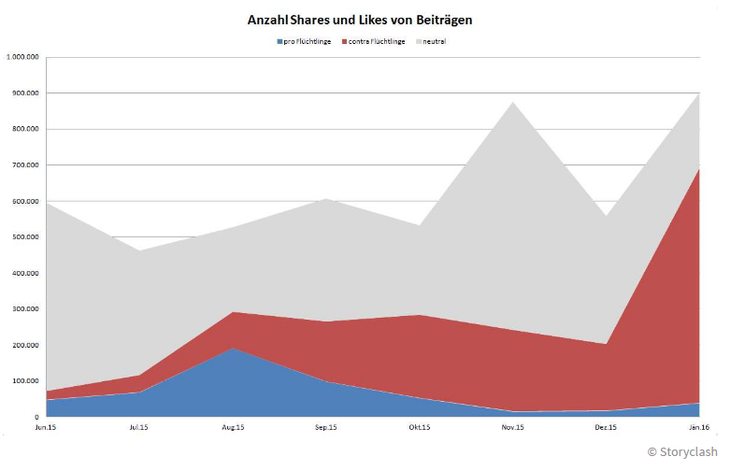
I have read a lot of articles in the last time about refugees. Due to the fact that the space is not infinite to show all articles, I restrict my outcomes only on three major articles, which show good the differences how media deals with the topic.
The first article “Justice minister: Attacks in Cologne were organized through social media networks”, which was published from standard.at in January 2016. The article has more than 1650 postings from the readers. The German justice minister warns against blanket judgements and he also thinks that the attacks in the night to New Years Eve were organized and planned before, maybe through social media.
According to “Bild am Sonntag”, citing confidential police reports told North African groups should apparently call compatriots through social media via Internet to come to Cologne central station.
That is one of several example of articles, which is not carefully researched or maybe to early published. The “Bild am Sonntag” is the most popular tabloid in Germany and it is known, that it is focused to attract readers. The next article refutes this fact that the attacks were planned or organized.
The article “BKA report on new year’s Eve: In 12 German countries same attacks such in Cologne”, published from tagesschau.de in January 2016 is based on the official report from the German Federal Police office and refute the statement that the attacks in Cologne were organized.
It is apparent, that this official report has more detailed and right information about the attacks in the night of New Year’s Eve. Moreover, the article doesn’t show how often it has been shared and there are also no comments above it.
The next article deals with a recent topic, which happened in Austria. The article from kurier.at in June 2016 “New built refugee hostel in Oberösterreich burned down: arson attack” tells about that there were two fire sources on outer wall. According to Red Cross and police it was arson attack and till now there is no hint, who is responsible for it. The damage amounted to 300.000 euros.
I have read articles from different newspapers related to this topic and they all reported the same information. The difference which I recognized was that the article from krone.at, for example, was quite shorter than the more detailed article from kurier.at. Moreover, there are 80 comments at the article from krone.at in comparison to the other articles.
The last article “How welcomed are refugees?”, published in May 2016 from the media house news.at tells about Surprising results of a survey by Amnesty International. Most people (80%) would worldwide Refugees welcomed with open arms. Many would be willing to house refugees in their own home. Amnesty International said that refugee policies of most governments pass public opinion. China is on the top of the list “refugees welcome index”, followed from Germany and Great Britain. On the last places are Russia, Indonesia and Thailand.
It is surprisingly that Great Britain is on the third place on the list of “refugee welcome index”, because the article “Attitudes harden towards refugees from Syria and Libya, BBC poll suggests”, published from BBC in February 2016 says the opposite. Attitudes towards allowing refugees into Great Britain have hardened, a survey for BBC Local Radio suggests. Two in five (41%) of the 2,204 people interviewed by Comres say Britain should accept fewer refugees from Syria and Libya.
The figure was 31% in September 2015. However, more than half of those surveyed (56%) supported refugees being placed in their local area once they are brought to the UK. (http://www.bbc.com/news/uk-england-35470723)
  - References
- Helsingin Sanomat (2015) “Turvapaikanhanhakijoiden ravintolasta tuli tämän ravintolapäivän hitti”, source:
http://www.hs.fi/kaupunki/a1448077773489

- The Daily Mail (2015) British woman behind stop immigrants and close UK borders’ petition which has gathered almost 500,000 signatures in wake of Paris attacks.”, source:
http://www.dailymail.co.uk/news/article-3323538/British-woman-stop-immigration-close-UK-borders-petition-gathered-500-000-signatures-lives-SPAIN.html

- The Guardian (2015a) “EU states failing to meet funding and resource commitments”, source:
https://www.theguardian.com/world/2015/nov/05/refugee-crisis-eu-states-not-doing-enough-says-european-commission

- The Guardian (2015b). “EU urged to focus funds on displaced Syrians in Middle East”, source:
http://www.theguardian.com/global-development/datablog/2015/nov/13/refugee-crisis-eu-european-union-urged-focus-funds-displaced-syrians-middle-east

- The Guardian (2016a). “Austria expatriates in Greece condemn Vienna over refugee crisis “, source:
https://www.theguardian.com/world/2016/mar/05/austrian-expatriates-greece-stinging-condemnation-refugee-crisis

- The Guardian (2016b) “How Greeks opened their hearts to strangers”, source:
https://www.theguardian.com/world/2016/mar/12/refugee-crisis-greeks-strangers-migrants

- The Guardian (2016c), “The idealists of Lesbos: volunteers at the heart of the refugee crisis”, source:
https://www.theguardian.com/world/2016/apr/15/idealists-of-lesbos-volunteers-refugee-crisis-pope-francis

- HS (27.11.2015) Turvapaikanhakija epäillään raiskanneen tytön Raisiossa – Kaupunginjohtaja: “Vastakkainasettelua pitäisi välttää” Source: http://www.hs.fi/kotimaa/a1448594695929 [27.6.2016]

- Turun Sanomat (3.5.2016) Tivolin Työntekijää epäillään törkeästä raiskauksesta. Source: http://www.ts.fi/uutiset/turun+seutu/864971/Tivolin+tyontekijaa+epaillaan+torkeasta+raiskauksesta [27.6.2016]

- HS (16.2.2016) Raision raiskausjutussa yli kolmen vuoden tuomio – mies väitti tytön olleen aloitteinen. Source: http://www.hs.fi/kotimaa/a1455593342761 [27.6.2016]

- HS (12.1.2016) Raision raiskausepäiltyn tutkinta valmis – Turvapaikanhakijaa epäillään nyt törkeästä raiskauksesta. Source: http://www.hs.fi/kotimaa/a1452568189716 [27.6.2016]

- Turun Sanomat (16.2.2016) 19-vuotiasta epäillään törkeästä raiskauksesta. Source: http://www.ts.fi/uutiset/turun+seutu/841298/19vuotiasta+epaillaan+torkeasta+raiskauksesta [27.6.2016]

- Trending topics
  - So teilte Österreich: Bissige Satire, Anonymous-Hacker & Flüchtlinge: Das sind die 50 meist geteilten Stories in Social Media (December 2015); source:
https://www.trendingtopics.at/so-teilt-oesterreich-2015/
  - Datenanalyse: Berichte über Flüchtlinge: Von der Willkommenskultur auf Facebook ist nicht viel übrig geblieben (February 2016); source:
https://www.trendingtopics.at/fluechtlinge-social-media-storyclash/

- Der Standard (January 2016) Justizminister: Angriffe in Köln waren über soziale Netzwerke organisiert; source:
http://derstandard.at/2000028773411/Justizminister-Silvester-Angriffe-auf-Frauen-waren-organisiert

- Tagesschau (January 2016) BKA-Bericht zu Silvester In zwölf Bundesländern Übergriffe wie in Köln; source:
https://www.tagesschau.de/inland/silvester-uebergriffe-bka-101.html

- Kurier (June 2016) Neugebautes Flüchtlingsheim in OÖ abgebrannt: Brandstiftung; source:
http://kurier.at/chronik/oberoesterreich/ooe-neugebautes-fluechtlingsheim-in-altenfelden-abgebrannt/202.028.416

- Kronen Zeitung (June 2016) Feuer in Flüchtlingsunterkunft war Brandstiftung; source:
http://www.krone.at/Oesterreich/Feuer_in_Fluechtlingsunterkunft_war_Brandstiftung-Belohnung_ausgelobt-Story-512848

- News (May 2016) Wie willkommen sind Flüchtlinge?; source:
http://www.news.at/a/amnesty-fluechtlinge-umfrage-6369596

- BBC News (February 2016) Attitudes harden towards refugees from Syria and Libya, BBC poll suggests; source:
http://www.bbc.com/news/uk-england-35470723

