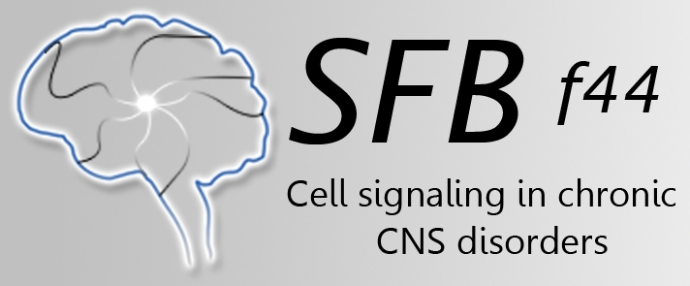
19th Lunch Discussion Meeting
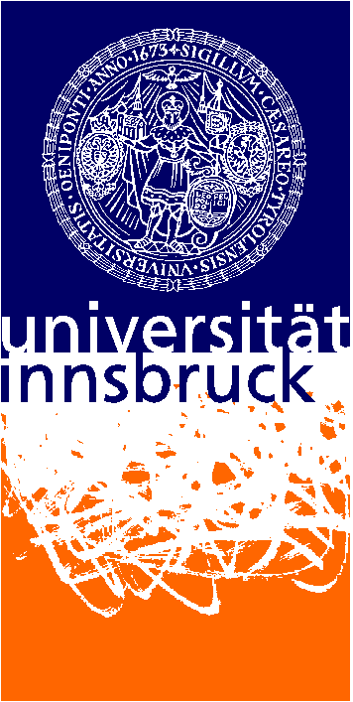
SFB Lunch Coordinators
Nadine Ortner & Conor Murphy
University of Innsbruck
Dept of pharmacology and toxicology
CCB, Innrain 80-82
A-6020 Innsbruck, Austria
Tel: 0043 - 6604293977
Email: Conor.Murphy@uibk.ac.at
Summary of activates,
Participants: 16

Date: 19th Jan 2017

At our last SFB Lunch Discussion Meeting on the 28. March, 2017, Mag. Kathrin Kähler and Dr. Nadine Ortner gave two very interesting seminars for our topic of interest;
"Which methods are we working on?"
The meeting lasted about 90 minutes, where we heard from Kathrin about everything from rationale, primer design and practical application in the use on implementation of real time quantitative polymerase chain reaction (Kathrin). Following a stimulating discussion, we were treated to the “in’s and out’s” of CRISPR/Cas design and uses by Nadine.
In the next SFB Lunch Discussion Meeting, we will continue to focus on other novel techniques that SFB participants are currently using. We will hear from Thomas Keil, Veronika Fontebasso and Eva-Maria Fritz on the delicate/detailed use of stereotactic surgeries in rodents to bring our understanding of the brain forward.

We kindly thank the SFB-44 consortium for providing refreshments!
Regards,
SFB Lunch Coordinators
Nadine Ortner & Conor Murphy

