PETRA-E Conversations:
Translating Children’s Literature
12:00 – 13:00 CET, Tuesday 11 November, online

Maria Pipeva, Associate Professor of British culture and literature at the Department of English and American Studies of Sofia University and Katharina Walter, Senior Lecturer at the Department of Translation Studies at the University of Innsbruck

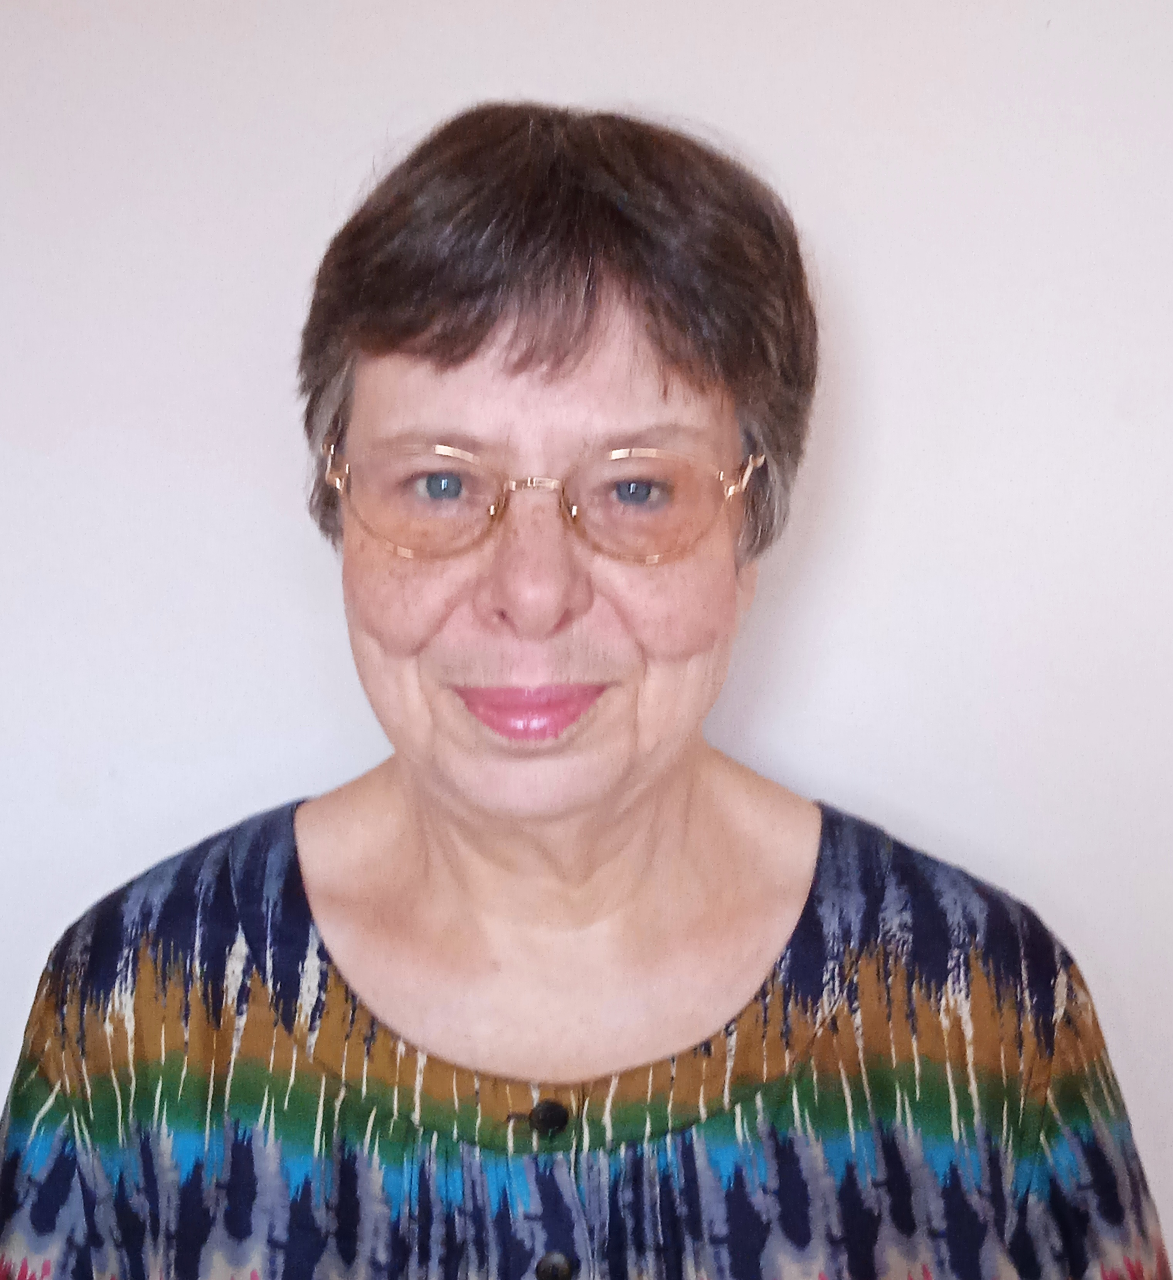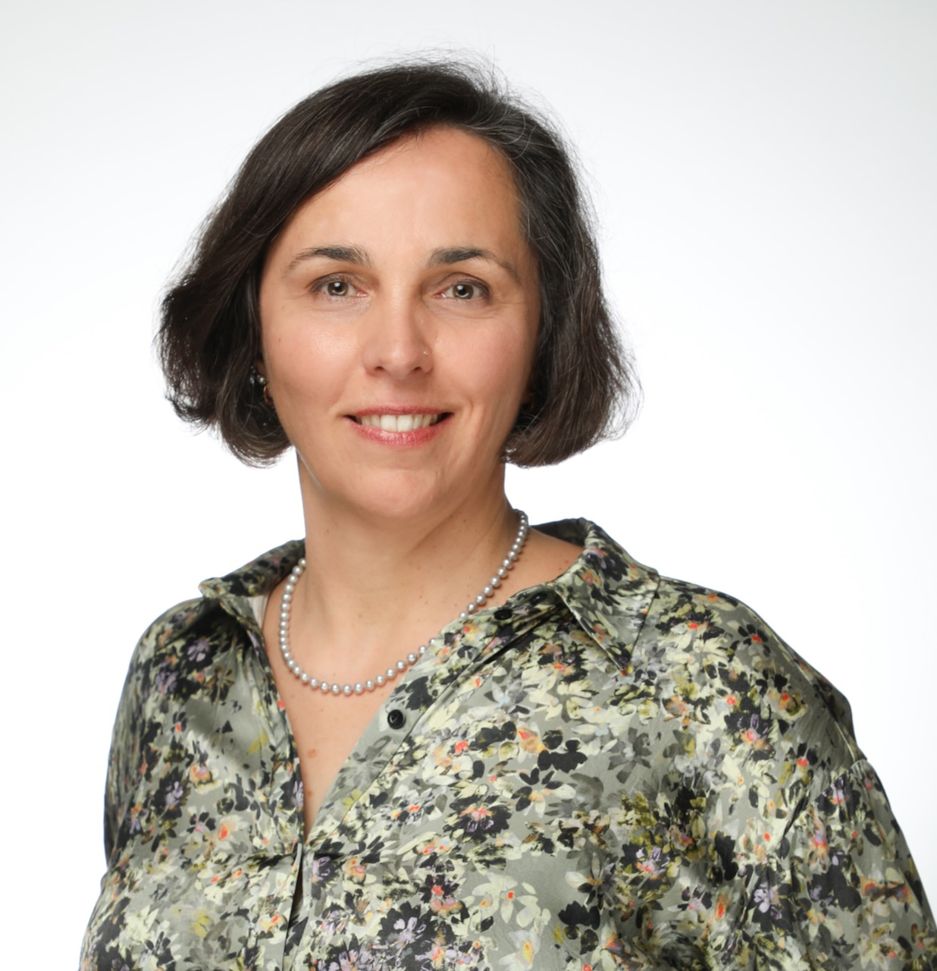

Join Maria Pipeva, Associate Professor of British culture and literature at the Department of English and American Studies at Sofia University and Katharina Walter, Senior Lecturer at the Department of Translation Studies at the University of Innsbruck for a discussion of the translation of children’s literature.

Maria and Katharina are planning to talk about the translation and retranslation of classic British children’s books, and trends in contemporary translation of literature for children, including languages, topics, the representation of diversity, translators' approaches, the use of AI in this genre and public perceptions of translation for children.

The 45-minute discussion will be followed by 15 minutes for Questions and Answers. Those attending will be able to type questions into the ‘chat’ section during the discussion. The recording of the event will be made available afterwards on the Library of the PETRA-E website, and on our social media, for non-PETRA-E Network members.

Here is the Zoom link for the event.
https://us06web.zoom.us/j/87599683069?pwd=I6Sn3gcTb8PbLXzQiG7L8fFd2SdcOR.1

Meeting ID: 875 9968 3069
Passcode: 5k6MmV

This event forms part of our series of PETRA-E Network Conversations. We will hold one Conversation each term.

