24th International Working Seminar on Production Economics Template Paper (17 points centered)

Ou Tang^{a,b}, Hubert Missbauer^{c} (13 points centered)

ªDivision of Production Economics, Department of Management and Engineering,
Linköping University, SE-581 83 Linköping, Sweden,
ou.tang@liu.se
^{b}Presenting author
^{c}Department of Information Systems, Production and Logistics Management,
University of Innsbruck, A-6020 Innsbruck, Austria
hubert.missbauer@uibk.ac.at
(italics, 10 points, centered)

Abstract
The Abstract should not exceed 250 words. (12 points, justified)
Keywords: Sample paper A4, MS Word, Welcome to Innsbruck. (12 points, left justified)

General Guidelines
For reasons of uniformity, all papers prepared with MS Word should use this “Word-template”. This file should be considered as the “instructions to authors”. Prepare your paper(s) by editing a copy of this file.

Please use Times New Roman and the font size should be 12 points throughout the text, unless indicated otherwise. The paper format should be A4 and please use 1.15 line spacing. Margins should be 2.5 cm except for the margin from above should be 3.5cm. The first line of each paragraph should be indented by 0.5cm. Please use page numbers at the bottom of the page, centered, and do not show numbers on first page. These numbers are temporary. Do not refer to a Page Number in text.

Note: This template paper is not to be read in any form or content. The conglomeration of equations and other text elements were put together solely for a typographical illustrative purpose.

Submitting Papers
Papers should be submitted in electronic form in the system https://www.uibk.ac.at/de/wipl/productioneconomics2026/ before January 14, 2026. When submitting, please use PDF format.

Page Limit
The page limit for contributed papers is 16 pages.

Title and Authors
The title should be in lower case with the first letter of major words capitalised.

Author affiliations should consist of “Department, Institution, City, State (if applicable), Postcode (if any), Country, and email address”, please indicate the presenting author after the affiliation.

Section Headings
5.1. And Sub-Section Headings (all subsection headings; italics, 12 points)
Section headings should be in lower case with the first letter of major words in upper case. Do not use sub-subsections more than exceptionally. Please do not use footnotes or end notes. Please check that headings are not on their own at the bottom of a page, at least two additional lines should follow. Take away an empty line at the top of a page, if this should appear.

Figures and Tables
All Figures and Tables should appear in the text near to where they are first referenced. Put table captions below the table. They should be centred and must not fall outside of the normal printed area of the page. The font size for all numbers and letters in the figure, as it appears in your paper, must be at least as large as that for the regular text (which uses 12 points). Captions should be 11 points and be centered and placed below the figures and tables. Insert a blank line before the table/figure and between the table/figure and its caption.

III
1 | 2 | 3
1 | 10 | 100
3 | 30 | 1
30 | 70  70 | 2.5  2.5

Table 1: This is an example of a table (10 points, centered).

If required, figures or tables can use the full width of the printed page.

Equations
Equations should be centered with a number flush against the right margin as Equation (1):
$0≥I+B+K+I+WS+{PE}^{20}$ (1)

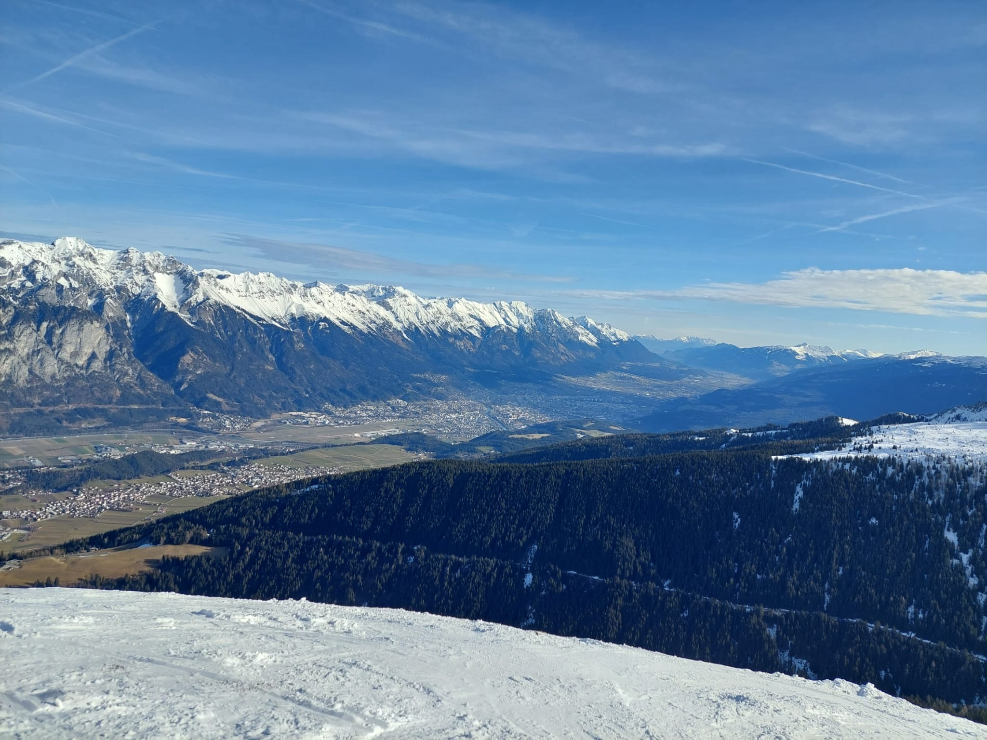
Figure 1: The beauty of the Inn-valley. Photo by Stefan Haeussler
In the text, this equation would be referred to as “(1)” or “Eq. (1)”. Please use Equation Editor or MathType. Please remember that equations are part of the running text, and should be ended with a full stop (period) if they finish the sentence, and with a comma, if a sub-sentence follows, and that the preceding text acknowledges the equation as part of the sentence (such as no full stop immediately preceding an equation). The equation number (1) thus follows on the same line that ends the equation.

Format for References
The references are listed as shown by the examples at the end of this paper and organised alphabetically according to surname of first author. They may be referred to by the author names and year. For example, Tu and Cheng (1998) or (Tu and Cheng 1998) or (Magazine, 1969; Karp, 1992).

Abbreviations
When abbreviating words, use the full stop (period) to replace the missing characters, and not after an abbreviation where the last character is the original. Examples: “Dr” (not “Dr.”), “Mr” (not “Mr.”), “Vol.” (not “Vol”), “No” (not “No.”). (@ Ou: I would delete this chapter).

Conclusions
You should include a brief conclusion section which summarises the results of your paper.

Acknowledgements (Optional)
Any acknowledgements should be immediately before the references. An unnumbered section may be used for thanks, etc.

Funding (Optional)
An unnumbered section may be used for grant details, etc.

Appendix/Appendices
Appendices are an unnumbered section and should be before the References. You may have more appendix sections (see below).

Appendix A. First Appendix
This is the first Appendix.

Appendix B. Second Appendix
This is the second Appendix.

List of References
All publications cited in the text should be presented in a list of references. All publications in this list should have a reference in the text. References should be in the following style (see below: first line justified to the left, other lines indented 0.5 cm).

Short Biography
Please provide a short presentation of all authors and their research interest below the List of references add two blank lines before the first author’s Biography.

References
Karp, R., 1992. Reducibility among combinatorial problems, in: Miller, R., Thatcher, J., Bohlinger, J. (Eds.), Complexity of Computer Computations. The IBM Research Symbosia Series. Springer Boston, MA, pp. 85-103.
Magazine, M., 1969. Optimal policies for queuing systems with periodic review. Thesis. University of Florida, USA.
Tu, C.C., Cheng, H., 1998. Spectral methods for graph bisection problems. Computers & Operations Research 25, 519-530. doi:10.1016/S0305-0548(98)00021-5.

Ou Tang (bold, 12 points, justified, no indent) is Professor of Production Economics at Linköping University, Sweden. He serves as the editor for the International Journal of Production Economics and is the past president of International Society of Inventory Research (ISIR). His research includes inventory modelling, manufacturing planning and control systems, closed loop supply chains, supply chain risk management, sustainable supply chain management and China related operations management issues.

Hubert Missbauer is Professor of Business Administration at the University of Innsbruck. His research interests include…please add…

