
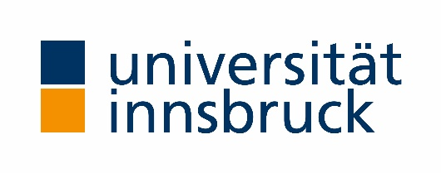

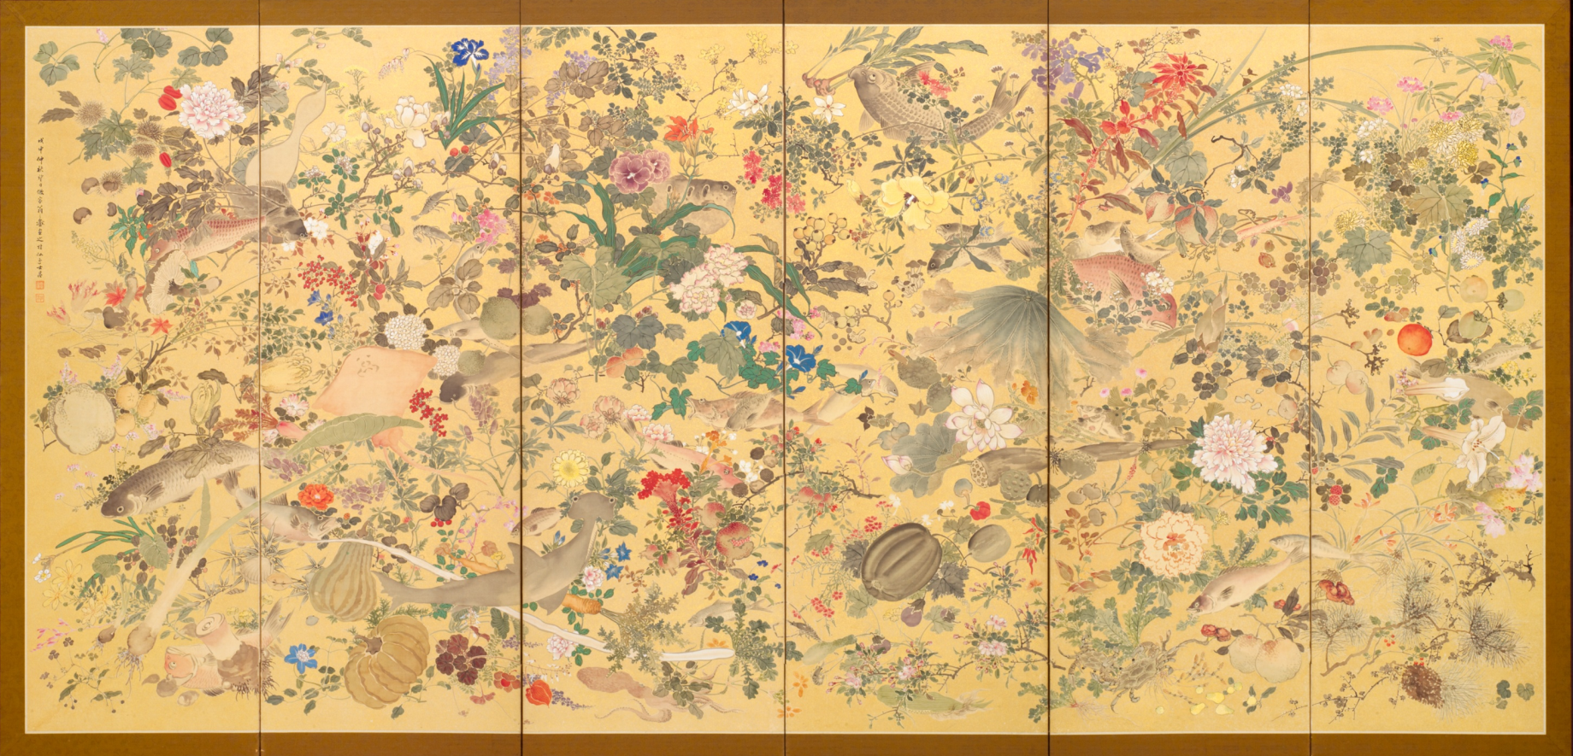
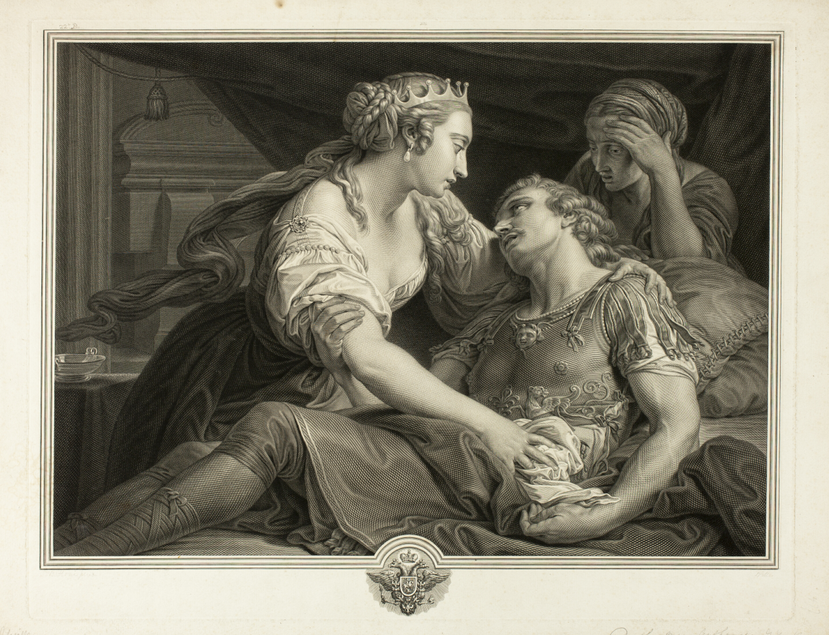

Johann Georg Wille. Death of Mark Antony, 1778. The Art Institute of Chicago.

Ikeda Keisen. Fish and Plants, 1908. The Art Institute of Chicago.

Systems Thinking about Chronic Illness:
Scientific Controversies and Gatekeeping

University of Innsbruck, 8-9 July, 2025
Faculty of Catholic Theology, Karl-Rahner Platz 1, Dekanatssitzungssaal

Health science is vulnerable to infiltration by bad science or pseudoscience, and relies heavily on gatekeeping to maintain its integrity. Gatekeeping, though necessary, is perilous. The history of science shows that gatekeepers may let in bad science or pseudoscience while keeping out important new ideas, due to cultural waves or commitment to entrenched frameworks. In the science of chronic illness, there is reason to think that just this is happening. The orthodox “biomedical model”, which posits body-mind dualism and sharp disciplinary boundaries, falls short in understanding and treating chronic illnesses, especially when clear physical causes are elusive. Yet promising systems-thinking alternatives, which posit mind-body unity and strong interdisciplinarity, are often dismissed by gatekeepers – including scientists, regulators, patient advocacy groups, and the media – as bad science or pseudoscience. Poor gatekeeping in health science can have disastrous consequences for patients and society. This interdisciplinary workshop brings together health psychologists, medical scientists, and philosophers of science to understand the situation and explore a way forward – both for chronic-illness research, and for illuminating the promise and pitfalls of gatekeeping in health science.

Tuesday, 8 July

9:00-9:40 Welcome, Mutual Introductions, and Whakawhanaungatanga

9:45-10:45 Michael Sharpe (Oxford, Psychiatry)
Mind, Morals, Medicine and ME

11:00-12:00 Rebecca Kennedy (Oregon, Medicine)
Rewiring Belief: Changing Minds About Mind-Body Medicine

Lunch

14:00-15:00 Phil Parker (London, Health Psychology)
Can New Ideas Overcome Outdated Ones? A Case Study of The Lightning Process - A Systems Thinking Approach to Health

15:10-16:10 Enno Fischer (Dresden, Philosophy)
“Excited Delirium Syndrome” or Asphyxiation? Evidential Practices in Forensic Medicine

16:25-17:25 Katherine Dormandy (Innsbruck, Philosophy)
Gatekeeping the Science of Chronic Illness

19:00 Informal dinner

Wednesday, 9 July

9:00-10:00 Jason Busse (McMasters, Canada, Medicine)
Challenges and (Potential) Solutions to Management of Persistent Physical Symptoms

10:00-11:00 Daniel Wehinger (Innsbruck, Philosophy)
Reuniting Body and Soul: The Cartesian Legacy and Contemporary Philosophy of Mind

11:15-12:15 Diana Walther (Fribourg, Medicine)
Electromagnetic hypersensitivity: the condition, the controversy and an exploration of a way forward

Lunch

14:15-15:15 Karin De Punder (Innsbruck, Psychology)
Early Life stress-induced Accelerated Biological Aging as a Risk Factor for Disease Susceptibility over the Lifespan

15:20-16:20 Bruce Arroll (Auckland, Medicine)
Concluding Remarks

16:40-17:40 Brainstorming future work

19:00 Workshop dinner

