Casting Call

InnScene will be performing a musical in November of 2026.
We will be casting five speaking roles to be filled. If you would like to be considered for a singing part as well, let us know at the audition.

When: 14 January 2026, 9-12am

Where: Coffee Room, English Department, Geiwiturm 3rd floor

What: In order to evaluate your suitability for our 2026 cast, we require you to come with the following monologue prepared:

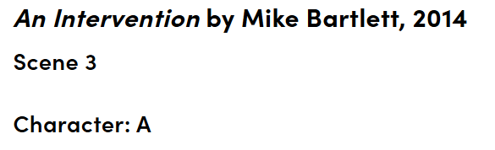
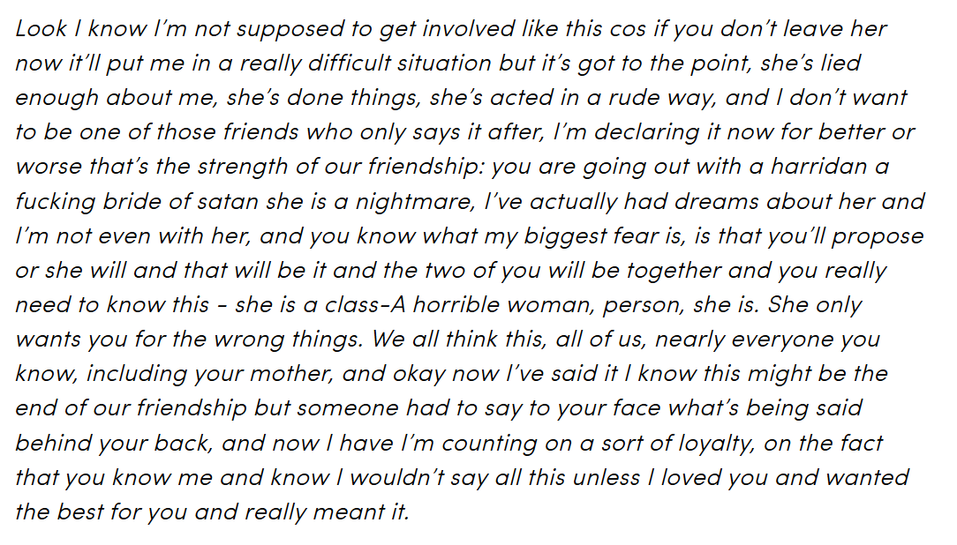

For efficiency, please register for your preferred time slot by inserting your name (or a pseudonym of your choice) in the list you’ll find put up on Prof. Dr. Kirner-Ludwig’s office door (Geiwiturm, 3rd floor, 40326).

Should you wish to be additionally considered for a singing role, please bring a prepared song (length: max. 1 min.)

Note: InnScene meets every week, on Mondays 3-5pm. If you register for our casting, we expect that you can and will commit to this weekly timeslot if you are accepted.

Unless you register, we may only be able to offer you short notice slots upon availability.

