Sensing Mountains – Digitising Landscapes for Environmental Monitoring
Martin Rutzinger¹, Magnus Bremer^{1,2}, Andreas Mayr², Thomas Zieher¹
¹Institute of Geography, University of Innsbruck, Austria
²Institute for Interdisciplinary Mountain Research, Austrian Academy of Sciences, Austria

Mountain Research is an interdisciplinary scientific field integrating research on the physical environment and human interaction in mountain areas aiming at support of sustainable development under current global change conditions. Relevant scientific disciplines connecting via Mountain Research are Geography, Geoscience, Geomorphology (e.g. Mayr et al. 2018), Environmental Sciences, Bioscience (e.g. Niederheiser et al. 2018), Forestry (e.g. Bremer et al. 2017), Agricultural Sciences, Tourism, Natural Hazard Research, Infrastructure, Construction and Planning, and Nature Protection. Sensing Mountains means the quantitative and contactless measurement of physical properties by observing mountain phenomena i.e. processes on a defined spatial extent, resolution and frequency of measurement repetition. This includes both remote sensing and close-range sensing techniques comprising satellite, airborne and terrestrial sensing platforms (Fig. 1). Sensing an object and phenomena of interest includes the enhancement or continuation of existing traditional field observations and reference data, which often exist only in a nested punctual manner. Hence, close-range sensing might bridge the gap between field measurements and satellite remote sensing whereas scaling and integration of measurements from different systems is still a matter of research (Zieher et al. 2018). Within this summer school, we provide inspiration for tackling new research questions in Mountain Research making use of sensing techniques. It is a contribution to the digitisation of mountain landscapes (Fig. 2). This comprises understanding of the phenomena of interest, tailored planning of a sensing monitoring campaign, handling of the measurement device, knowledge of the data processing methods and information extraction tools, interpretation of the accuracy of the data and results (Rutzinger et al. 2018). Additionally, sensing mountains aims at a high degree of automation of analysis, which requires programming skills. This allows area-wide processing and analysis of time series and ensures the repeatability and transferability of methods, which is today required for open science as well.

Bremer, M., Wichmann, V. & Rutzinger, M. (2017). Calibration and Validation of a Detailed Architectural Canopy Model Reconstruction for the Simulation of Synthetic Hemispherical Images and Airborne LiDAR Data. Remote Sensing. 9(3), 1-22.
Mayr, A., Rutzinger, M., Bremer, M., Oude Elberink, S., Stumpf, F. & Geitner, C. (2017). Object-based classification of terrestrial laser scanning point clouds for landslide monitoring. The Photogrammetric Record. 32(160), 377–397.
Niederheiser, R., Rutzinger, M., Bremer, M. & Wichmann, V. (2018). Dense image matching of terrestrial imagery for deriving high-resolution topographic properties of vegetation locations in alpine terrain. International Journal of Applied Earth Observation and Geoinformation. 66, 146-158.
Rutzinger, M., Bremer, M., Höfle, B., Hämmerle, M., Lindenberger, J., Oude Elberink, S., Pirotti, F., Scaioni, M., Wujanz, D. & Zieher, T. (2018). Training in innovative technolgies for close-range sensing in alpine terrain. ISPRS Annals of the Photogrammetry, Remote Sensing and Spatial Information Sciences. IV-2, 239-246.
Zieher, T., Toschi, I., Remondino, F., Rutzinger, M., Kofler, C., Meija-Aguilar, A. & Schlögel, R. (2018): Sensor- and scene-guided integration of TLS and photogrammetric point clouds for landslide monitoring. The International Archives of the Photogrammetry, Remote Sensing and Spatial Information Sciences. Riva del Garda, Italy. XLII-2, 1243-1250.
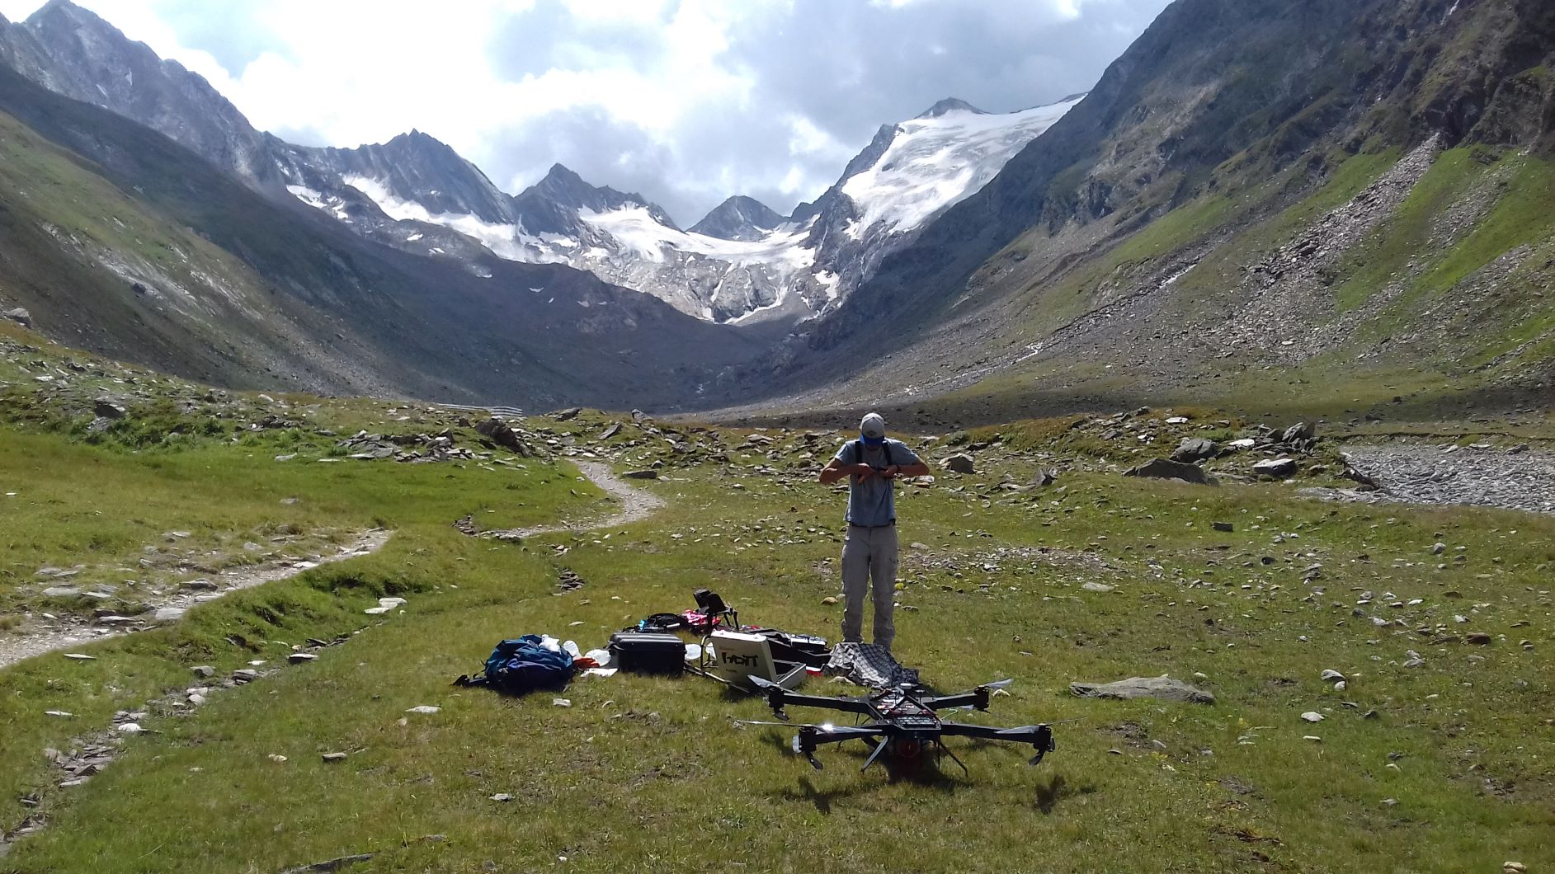
Figure 1: Unmanned aerial vehicle laser scanning in Rootmoos Valley (Ötztal, Austria). Foto by Rutzinger, M. 2018.

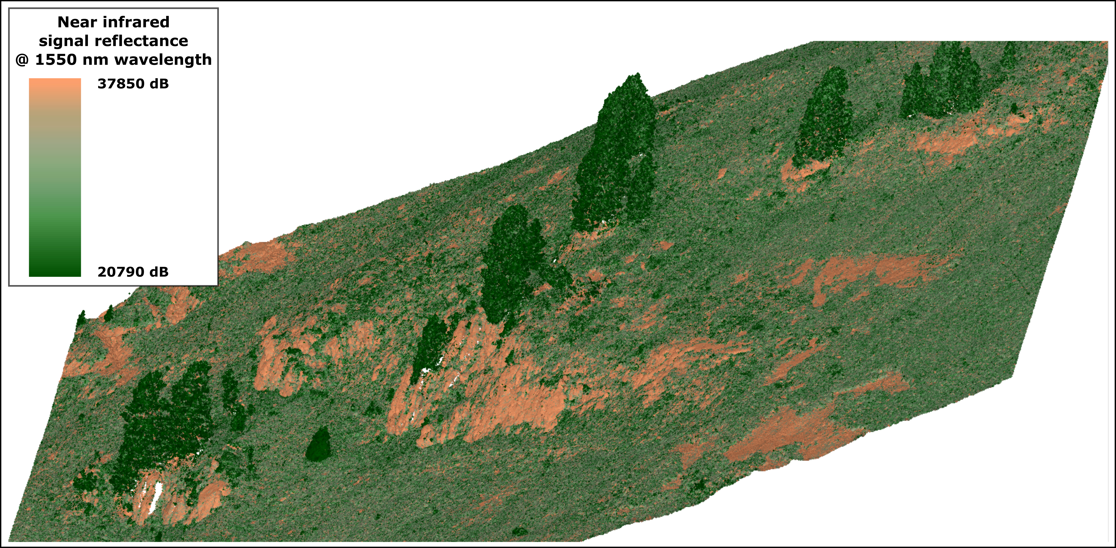
Figure 2: Near infrared colored point cloud from Unmanned aerial vehicle laser scanning. Figure by Mayr, A. 2019.

