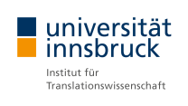
International Conference „New Words and Linguistic Purism“
25-26 October 2018
Department of Translation Studies – University of Innsbruck

Registration Form for Participants

Please send the completed registration form together with a confirmation of conference fee payment and, if applicable, a copy of your student ID to nwlp.2018@gmail.com.

Title
First name
Surname
Gender | female |  |  | male
Affiliation

E-Mail

Address

Postal Code

City

Country

Category of Participation | with presentation |  | without presentation
Title of Presentation

Co-Author(s) (if applicable)

Do you wish to participate in the Conference Dinner? | yes | yes (vegetarian) |  |  | no

Please note: In case of co-authored presentations, ALL authors (not only corresponding author) wishing to participate in the conference must register!

