The Italien-Zentrum together with the American Corner Innsbruck and in cooperation with Vier und Einzig invite you to

Performance & Discussion
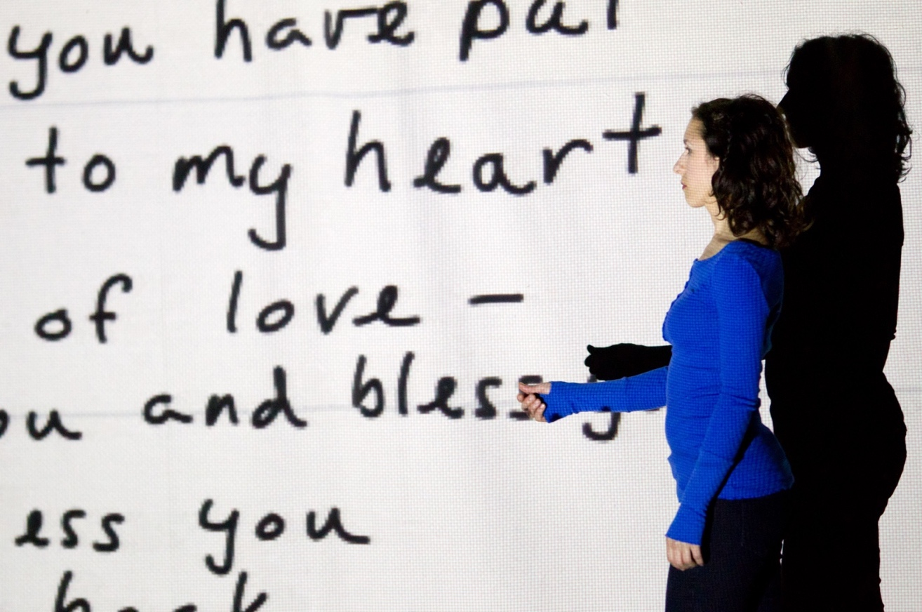
All I wanted to say

‘All I wanted to say’ is a multidisciplinary journey through theatre, dance, poetry, film, digital art, and music that explores both how we choose to communicate in the Digital Era and how these modes have transformed through time. A close look at the poetry, letters, text messages, and emails we all send can reveal how much remains untold.
‘All I wanted to say’ presents a reflection on technology’s major role in how, when, and what we say. Through a collage investigation of new and found texts as they intersect with projection, voice-over, chat room artifacts, and performance dialogue, we seek to immerse the audience in a bath of language and image that traverses communication and poetic expression over time and genres.

Time: Fr, 10 June 2016, 8:00 p.m. (20:00)
Place: Vier und Einzig,
Studio 3, Hallerstr. 41, 1. Stock, Innsbruck

This event is free and open to the public.
“Donations accepted”

Written, directed and performed by: Silvia Girardi
Performer on screen: Giuliano Pirotello
In collaboration with: poet Allison DeLauer, Film Collective ModoFilm, choreographer Folawole, musician Matt Venuti and digital artist Tim Roseborough

Weitere Informationen: http://www.uibk.ac.at/italienzentrum/
Photo @Elazar Harel

