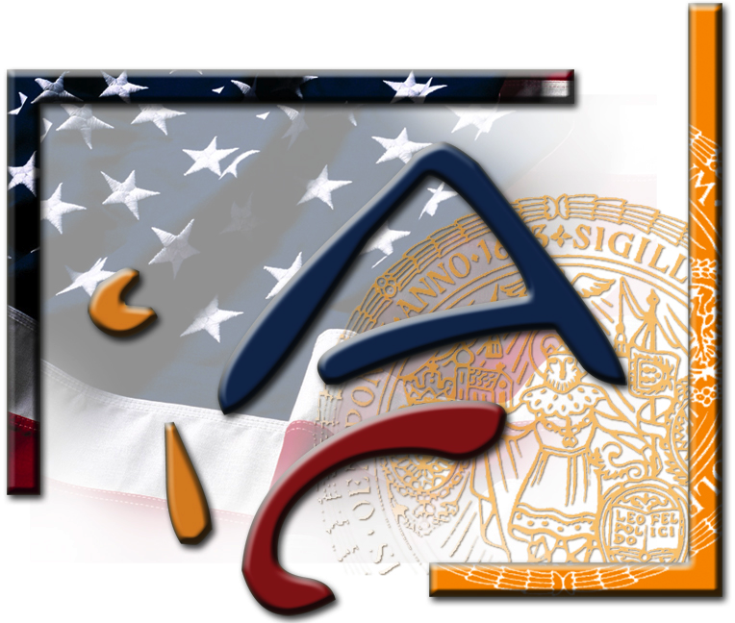

The American Corner Innsbruck

invites you to Meet

Robert Greenan
Counselor for Public Affairs, U.S. Embassy Vienna

Mr. Robert Greenan, Public Affairs Officer at the U.S. Embassy in Vienna, will be making his first official visit to Innsbruck on Friday, 29 May. Mr. Greenan is a high-ranking Embassy official, heading the Public Affairs Section. This is the section with which the American Corner Innsbruck is affiliated.

Following a morning of meetings at the ACI and lunch with some students, Mr. Greenan would be pleased to welcome you at an informal meet-and- greet with beverages and home-baked American cookies:

Friday, 29 May, 2015
13.00-14.00Uhr/1:00-2:00pm
Galerie Claudiana
Herzog-Friedrich-Strasse 3, 6020 Innsbruck

Registration is not required, but greatly appreciated:
americancorner@uibk.ac.at
(0512) 507-32808

